**SARVAJANIK COLLEGE OF ENGINEERING AND TECHNOLOGY**

**Add Placemark &**

**Identify the Optimal Path**

**Add Placemark**

## **Introduction :**

This report aims to provide a detailed analysis of integrating a placemark feature on Google Earth Pro for both personal locations, such as the home, and significant educational sites like the Sarvajanik College of Engineering & Technology. By leveraging the placemark functionality, users can enhance their geographical understanding and navigation efficiency.

#### **Objectives :**

1. **Explore the Placemark Feature**: Understand the functionality and benefits of using placemarks in Google Earth Pro.
2. **Add Placemarks for Key Locations**: Provide a step-by-step guide to adding placemarks for home and Sarvajanik College.
3. **Analyze the Benefits**: Discuss the advantages of using placemarks for personal and academic purposes.

#### **Benefits of Using Placemarks :**

* + **Enhanced Navigation**: Easily locate important personal and educational sites.
  + **Information Sharing**: Share placemarks with friends or colleagues for collaborative projects or meetups.
  + **Visualization of Data**: Users can visualize geographic data related to home and educational institutions effectively.
  + **Personalized Experience**: Customizable icons and descriptions allow for a tailored experience
* **How to add placemark :**

**Process** :

1. **On your computer, open Google Earth.**

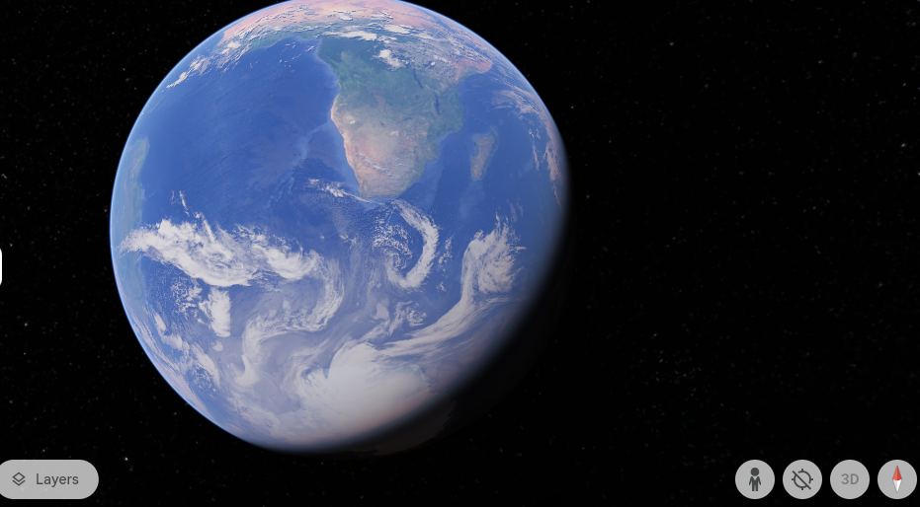

2 . [Navigate to the place you want to save](https://support.google.com/earth/answer/148186).

**For Home :**

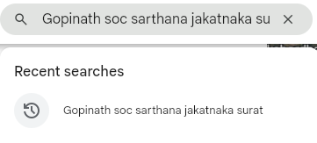

**For college :**

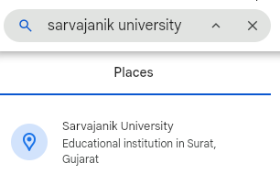

**3 . Above the map, click Add Placemark**

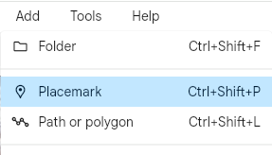

**4.In the new window, next to "Name," enter a placemark name.**

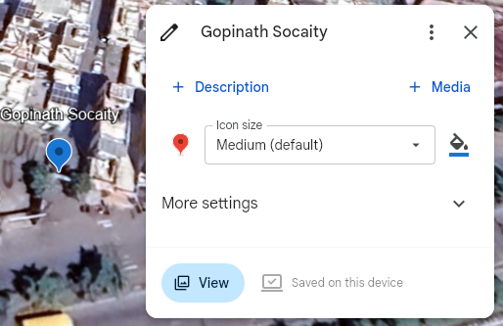

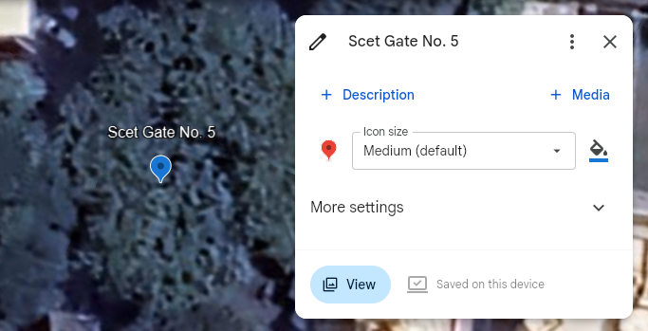

**5 . To choose a different placemark icon, to the right of the "Name" field, click the button** .

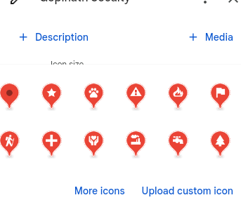

#### **Understanding the Placemark Feature :**

Google Earth Pro's placemark feature allows users to mark specific locations on the globe, providing a visual reference that can be saved, shared, and revisited. Each placemark can be customized with names, descriptions, and even images, making it a versatile tool for both personal use and educational purposes.

**Identify the Optimal Path**

### **Introduction :**

This report presents a comprehensive analysis of three potential routes between Gopinath Socaity sarthana jakatnaka, Surat, and the Sarvajanik College of Engineering and Technology. Utilizing the path feature in Google Earth Pro, we will evaluate each route by considering key factors such as distance, travel time, road conditions, and accessibility. The goal is to identify the optimal commuting path that balances efficiency and convenience for users.

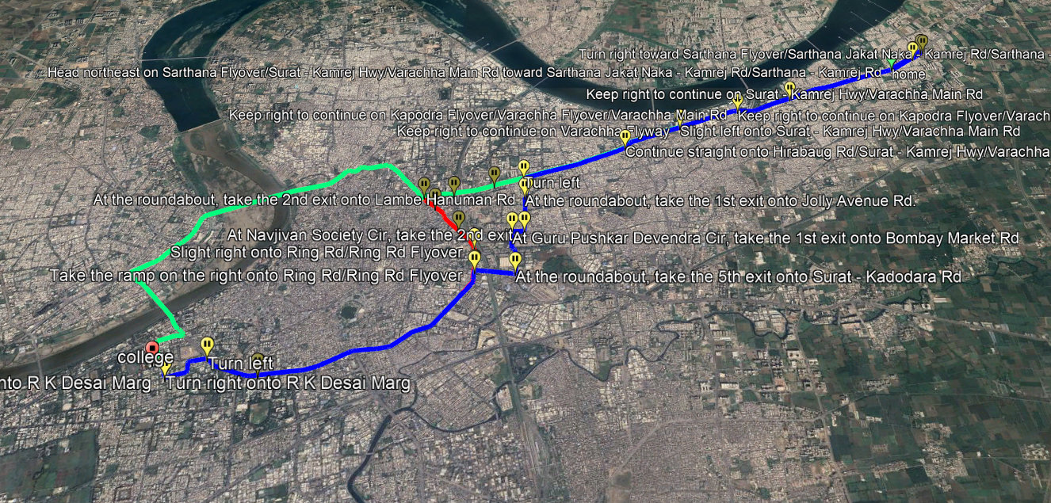

* **Route Analysis :**
* **Route 1: Surat-Kamrej Highway :**
  + **Distance :** 15 kilometers
  + **Time** : More than 45 minutes
  + **Description :** This route follows the main highway connecting Surat and Kamrej, offering direct access and potentially faster travel times.
  + **Key Points:**
    - Offers the shortest distance between the two locations.
    - May experience heavy traffic during peak hours.
    - Provides access to major amenities along the highway

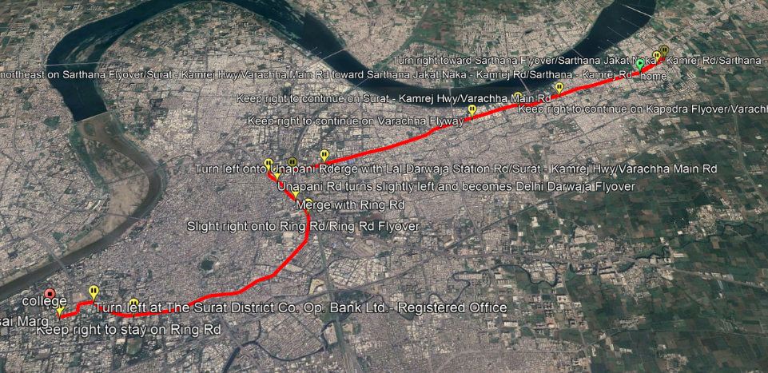

* **Route 2: Valthan–Punagam Road :**
  + **Distance :** 15 kilometers
  + **Time** : More than 40 minutes
  + **Description:** This route involves a detour through Valthan and Punagam, potentially adding to travel time
  + **Key Points:** 
    - Offers a more scenic route with less traffic congestion.
    - Provides access to local markets and attractions
    - May be slightly longer in terms of travel time

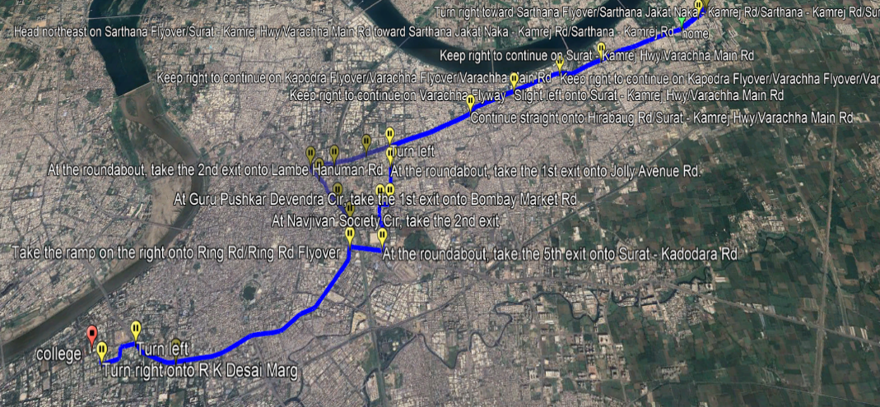

* **Route 3: Sarthana Jakat Naka - Mota varacha Road**
  + **Distance :** 15 kilometers
  + **Time :** More than 30 minutes
  + **Description:** This route takes a more indirect path through Sarthana and Jakat Naka.
  + **Key Points:** 
    - Offers a mix of urban and rural landscapes.
    - May have less traffic congestion than Route 1 during peak hours.
    - Provides access to various amenities along the route.

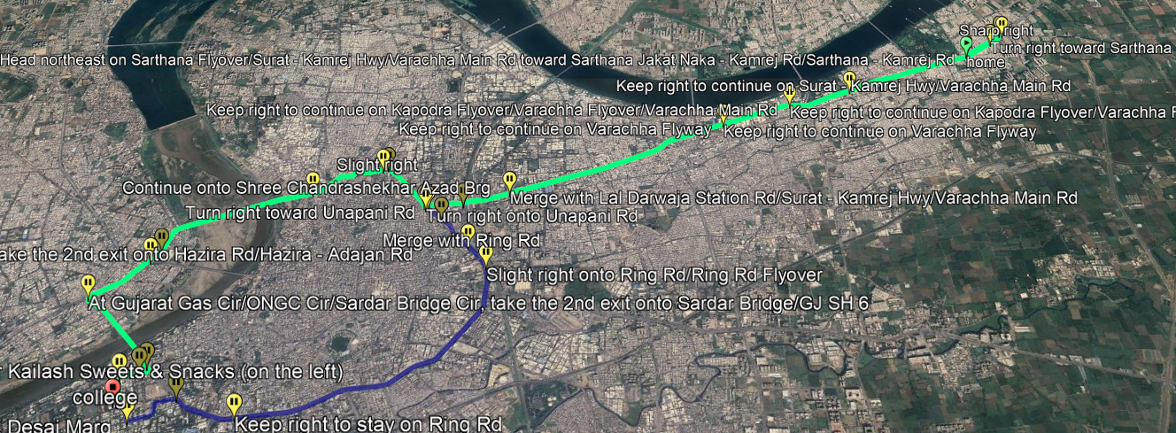

* **Optimal Path Recommendation :**

Based on the analysis, Route 3 (Sarthana Jakat Naka - Mota varacha Road) is generally the most efficient option due to its shorter distance. However, Route 1 (Surat-Kamrej Highway Road) and Route 2 (Valthan–Punagam Road) might be a viable alternative for those seeking a more scenic route or avoiding heavy traffic.

### **Factors to Consider :**

* + **Travel Time**: In addition to distance, it's crucial to consider real-time traffic data for a more accurate estimate of travel duration. Utilize Google Maps or similar navigation apps to evaluate current traffic conditions.
  + **Road Conditions**: Stay informed about any road construction, closures, or other factors that may impact travel time or safety.
  + **Personal Preferences**: Take into account your own preferences regarding road types, scenic views, and amenities available along the route.
  + **Public Transportation**: If you’re considering public transportation, assess factors such as frequency of service, overall travel time, and associated costs.

#### **Advantages :**

* + **Travel Time**:
    - **Accurate Estimates**: Real-time traffic data provides a clearer picture of expected travel times, helping to avoid delays.
    - **Dynamic Routing**: Navigation apps can suggest alternate routes to bypass congestion.
  + **Road Conditions**:
    - **Safety Awareness**: Staying informed about construction or closures enhances safety and reduces the risk of unexpected disruptions.
    - **Improved Planning**: Knowing the state of the roads helps in planning trips more effectively.
  + **Personal Preferences**:
    - **Enhanced Experience**: Choosing routes based on preferences (scenery, amenities) can make travel more enjoyable.
    - **Comfort**: Selecting familiar or preferred road types can lead to a more comfortable journey.
  + **Public Transportation**:
    - **Cost-Effective**: Public transport can be a cheaper alternative, reducing expenses related to fuel and parking.
    - **Reduced Stress**: Using public transport allows travelers to relax rather than focus on driving.

#### **Disadvantages :**

* + - **Travel Time**:
      * **Variability**: Traffic conditions can change rapidly, making real-time estimates sometimes unreliable.
      * **Over-Reliance on Apps**: Dependence on navigation apps may lead to stress if technology fails or if users misinterpret data.
    - **Road Conditions**:
      * **Inconsistent Information**: Not all road condition updates are timely or accurate, leading to potential surprises during travel.
      * **Limited Flexibility**: Being overly cautious about road conditions might lead to longer detours.
    - **Personal Preferences**:
      * **Subjectivity**: Personal preferences can vary widely, making it challenging to find a universally optimal route.
      * **Potentially Longer Routes**: Choosing scenic or preferred routes may result in longer travel times.
    - **Public Transportation**:
      * **Inconvenience**: Public transport schedules may not align with personal travel plans, leading to longer wait times.
      * **Limited Coverage**: In some areas, public transportation options may be limited or unavailable, making it impractical.

**Conclusion :**

* + **Add placemark :**

In summary, utilizing the placemark feature in Google Earth Pro significantly enhances the ability to identify and navigate to important locations. By adding placemarks for key sites, such as Shree Villa Residency and Sarvajanik College of Engineering & Technology, users can create a personalized mapping experience that facilitates better navigation and organization of information.

* + **Optimal Root finding:**

Furthermore, by evaluating potential routes between these locations, considering factors like travel time, road conditions, personal preferences, and public transportation options, we can determine the optimal path for commuting. This comprehensive approach not only improves the efficiency of travel but also enhances the overall experience by ensuring that routes align with individual needs and preferences.

Overall, the integration of placemarks and careful route assessment empowers users to make informed travel decisions, leading to safer and more enjoyable journeys.